# CSC 107 2.0

# Introduction to Computer Programming

**FINAL ASSIGNMENT**

**PROJECT REPORT**

M.A.S.MAHINSA

AS2019438

AS95334

19/AS-P/438

Content

1. Introduction
2. Functionality
3. Main function
4. Other functions
5. Data structures
6. Validations
7. File Handling
8. Bugs
9. Limitations

# **INTRODUCTION**

XYZ Distributors has number of vehicles to distribute our products island wide. Every day morning we load certain amount of items to our vehicles and keep records of those loadings. When unloading, sales records would be added to the sale file. In both cases, the stock record update accordingly.

The XYZ Distributors Data Recording System is mainly develop to perform the tasks given below;

.

* Loading details
* Unloading details
* View load/unload reports
* Sales records
* Sales progress
* Stock management

1. **Functionality of the system**
2. Main functions

XYZ distributions management system consists of 10 main functions namely;

* Main
* Main menu
* Loading items to the vehicle
* Unloading items from the vehicle
* View load/unload reports
* Sales record
* Progress
* Stock details
* Exit

1. Main

This is performed by main(); function of the system.

**Beginning:**

This is performed by the main() of the system and it is created for the creative beginning for the system.

**Enter password:**

In this user must be able to enter correct password to start the record system and the verification code is performed in the main() of the program system. And the protection was used for password in order to enhance the security of the system.

This is important for ensure the security of the system and for trustworthy of user.

The password cannot be changed while using the system , cause it hard-corded in the program.

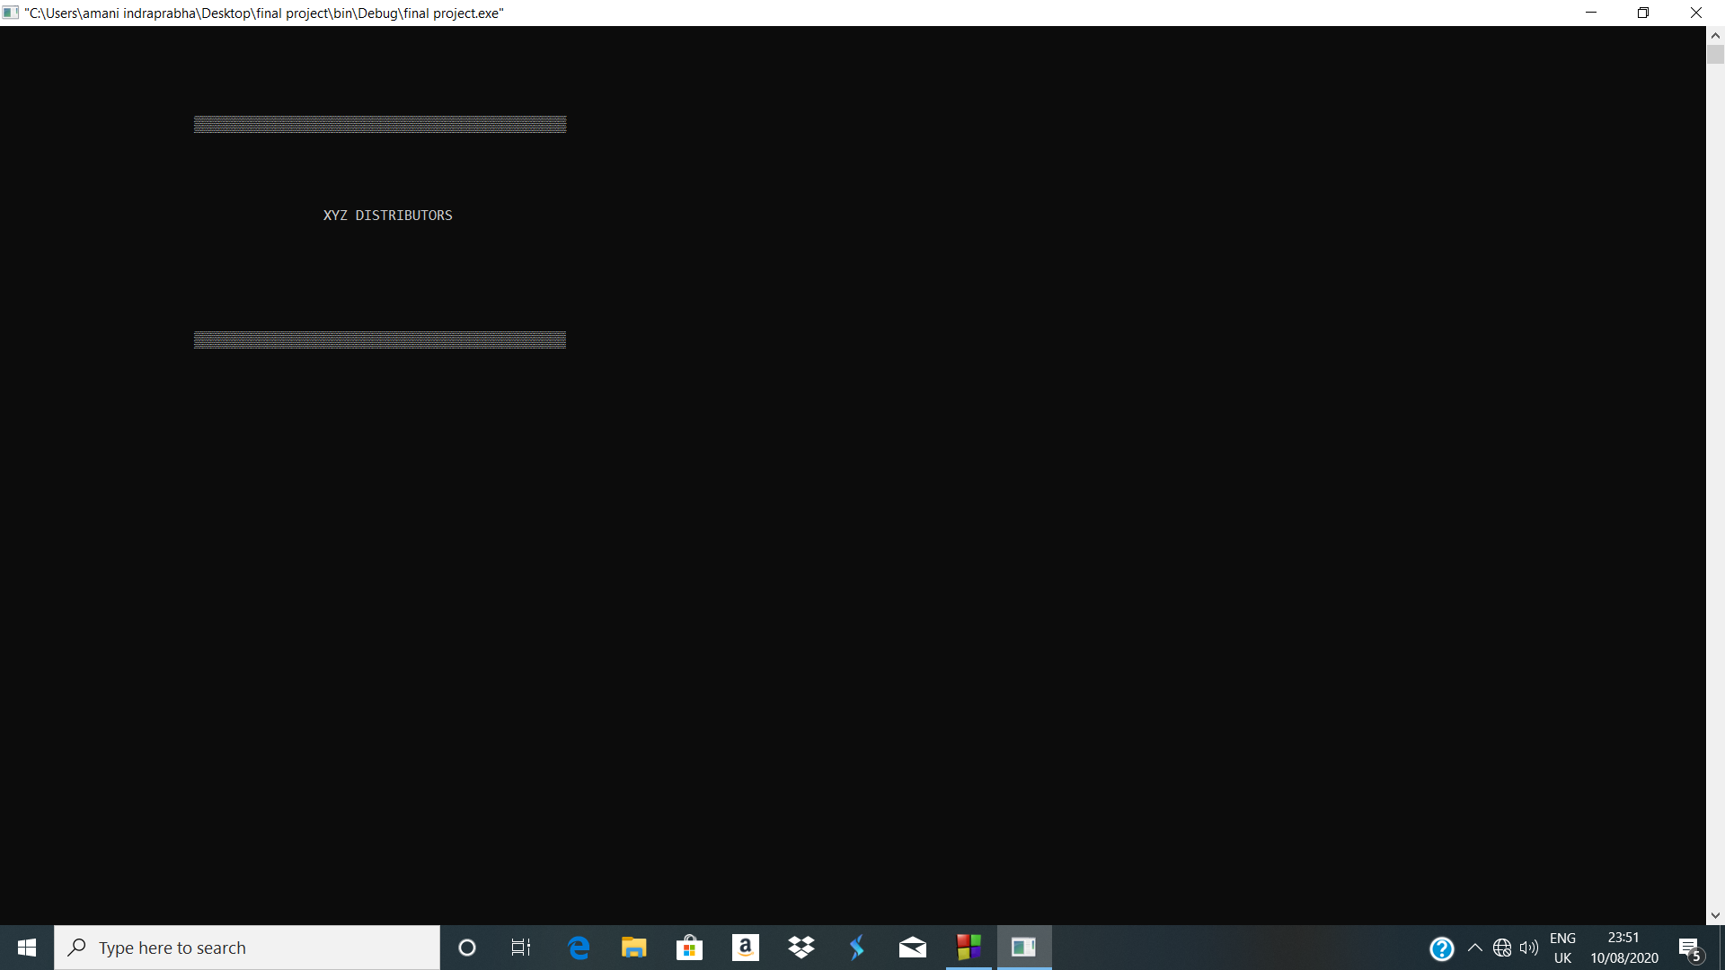

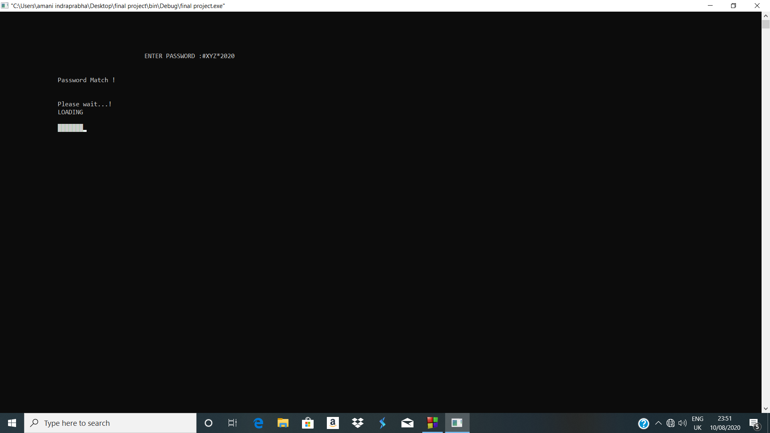

1. Main menu

Main menu is used to access the main functions in the record system.

In this program its declared as mainMenu() and there are 7 choices that will make easy to handle the all the activities.

There are;

* Enter Loading details of items
* Enter loading details of items
* View unloading and unloading records
* View stock record
* Sales progress
* View sales record
* Exit from the system

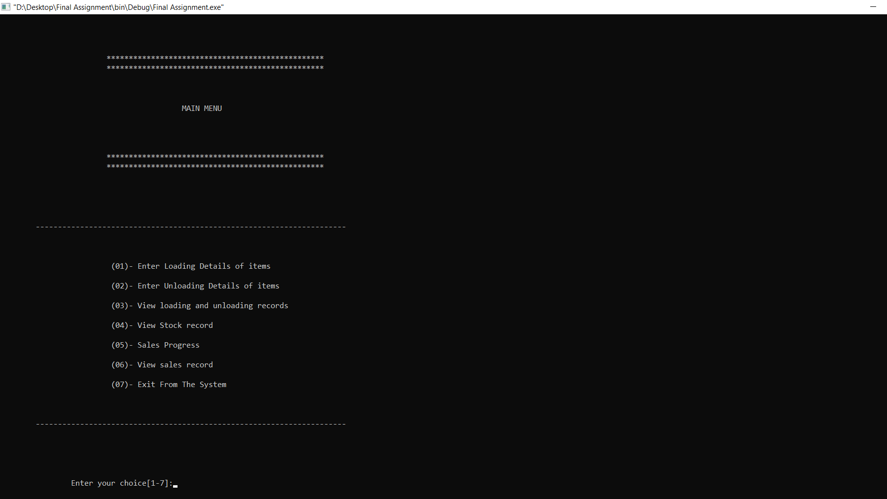

When the choice of user is not match, the system will tell to EXIT or go back to MAIN MENU.

[01].Enter loading details of items

Loading record is one of the main function in this sytem and also main activity of the company.

First of all the name of the sales man and identity number at the work place(XYZ distributors) are insert to the system and then the all the loadings details of the salesman can be added to the system for the current date.

Finally the system will successfully get the all entered details.

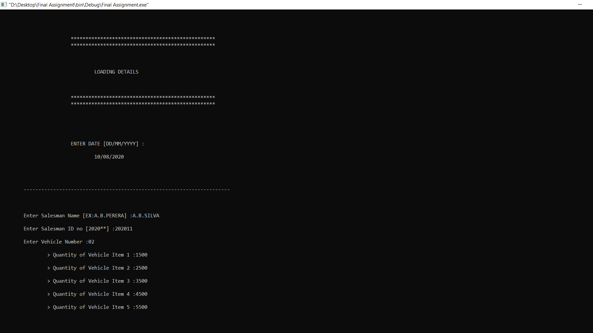

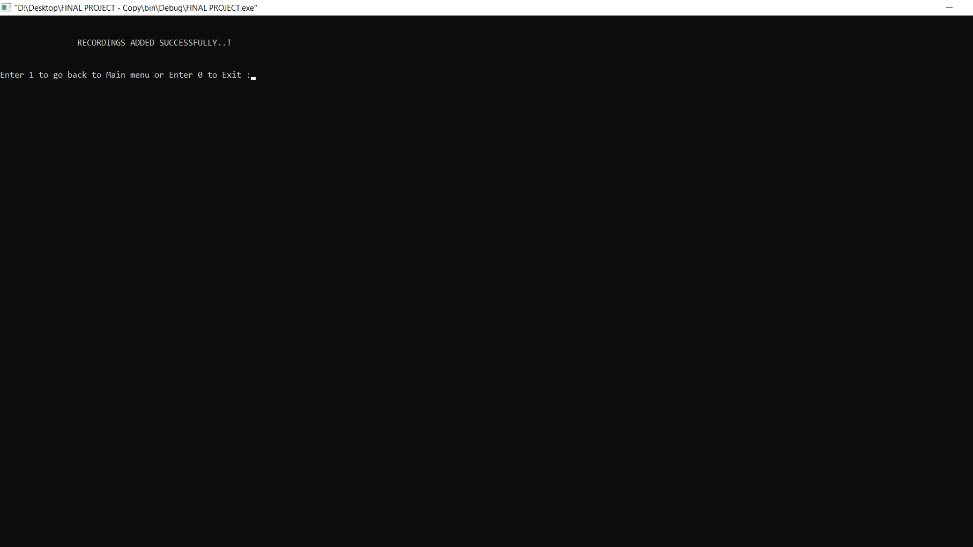

After that, the system will tell to EXIT or go back to MAIN MENU.

[02] .Enter unloading details of items

Un-Loading record is also one of the main function in this sytem and also main activity of the company. This will be added to the system after the delivering the loaded items in Island wide.

First of all the name of the sales man and identity number at the work place(XYZ distributors) are insert to the system and then the all the un-loadings details of the salesman can be added to the system for the current date.

Then user can enter unload details of a vehicle.

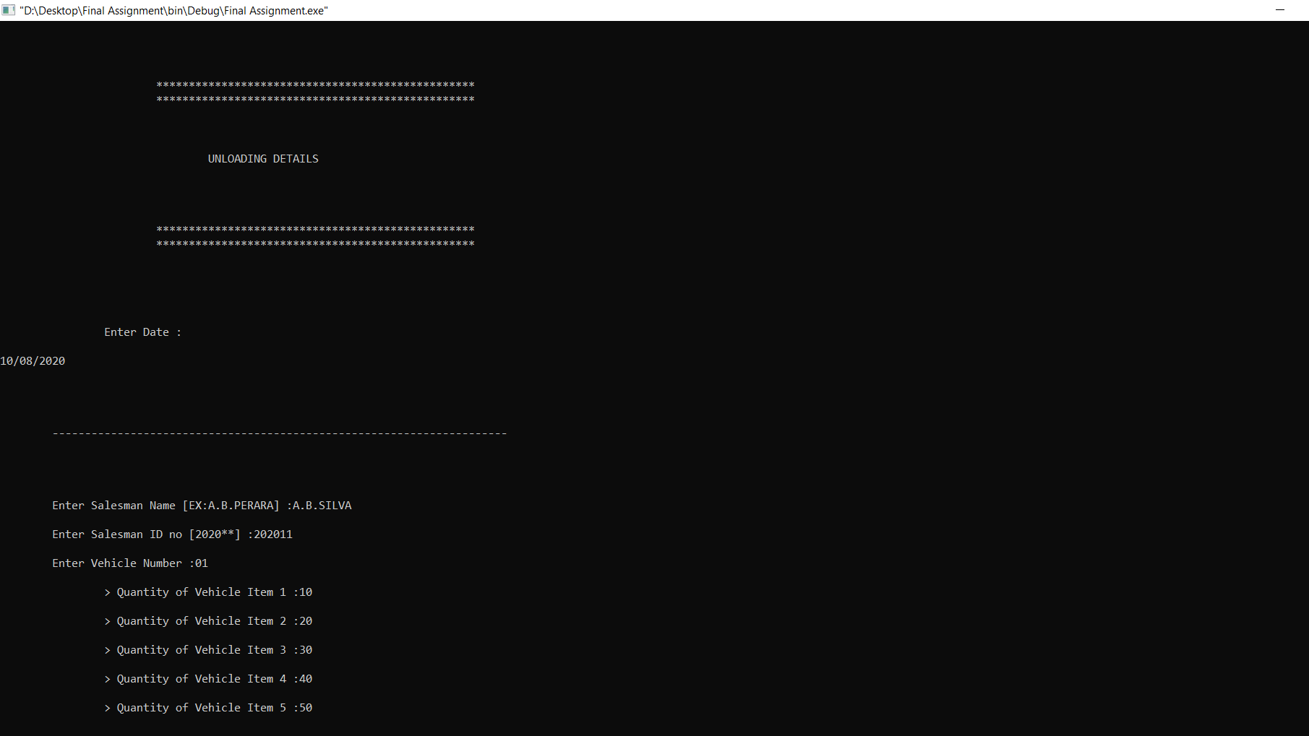

**

After that, the system will tell to EXIT or go back to MAIN MENU.

[03].View unloading and unloading records

This is show the report of load/unload data for the current date.

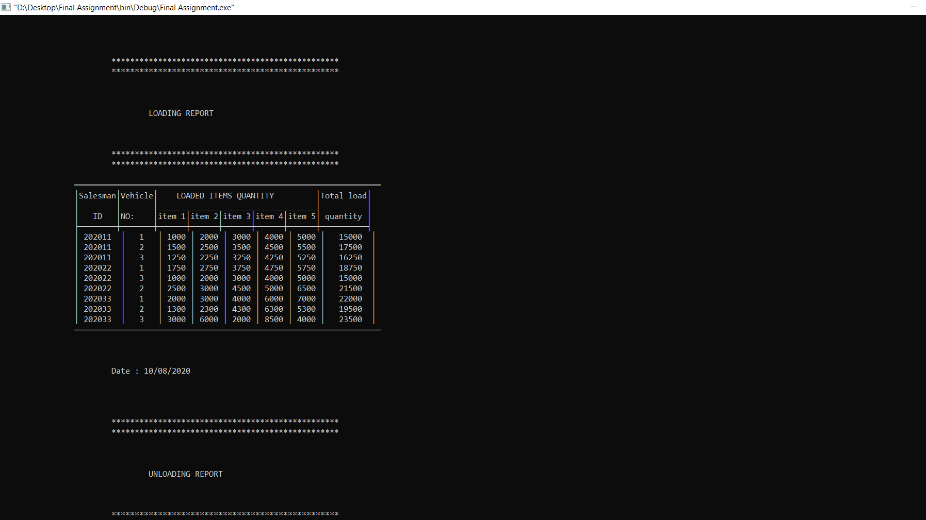

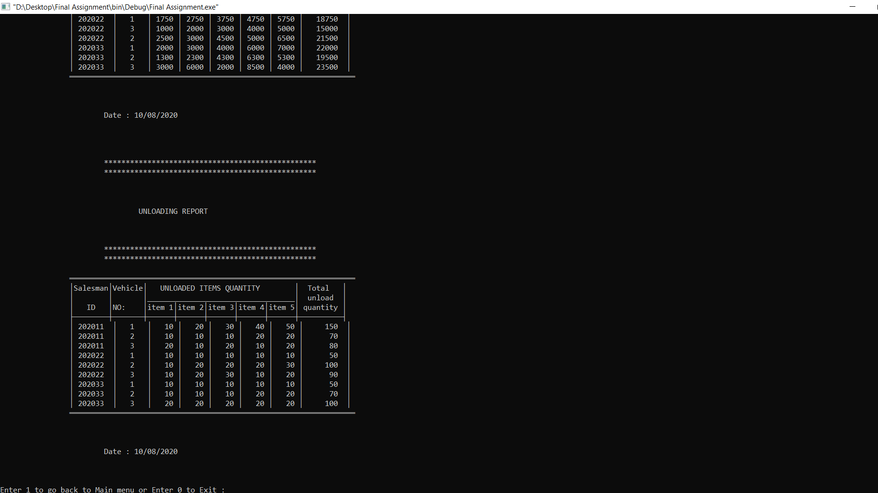

[04].View stock record

Stock record is one of the main function in this sytem and also it show the vehicle quantity at the company stock.

I`ve declared it as the stock(); function .

First all the stock details of the company stock is added to the system for the current date.

Finally the system will successfully get the all entered details.

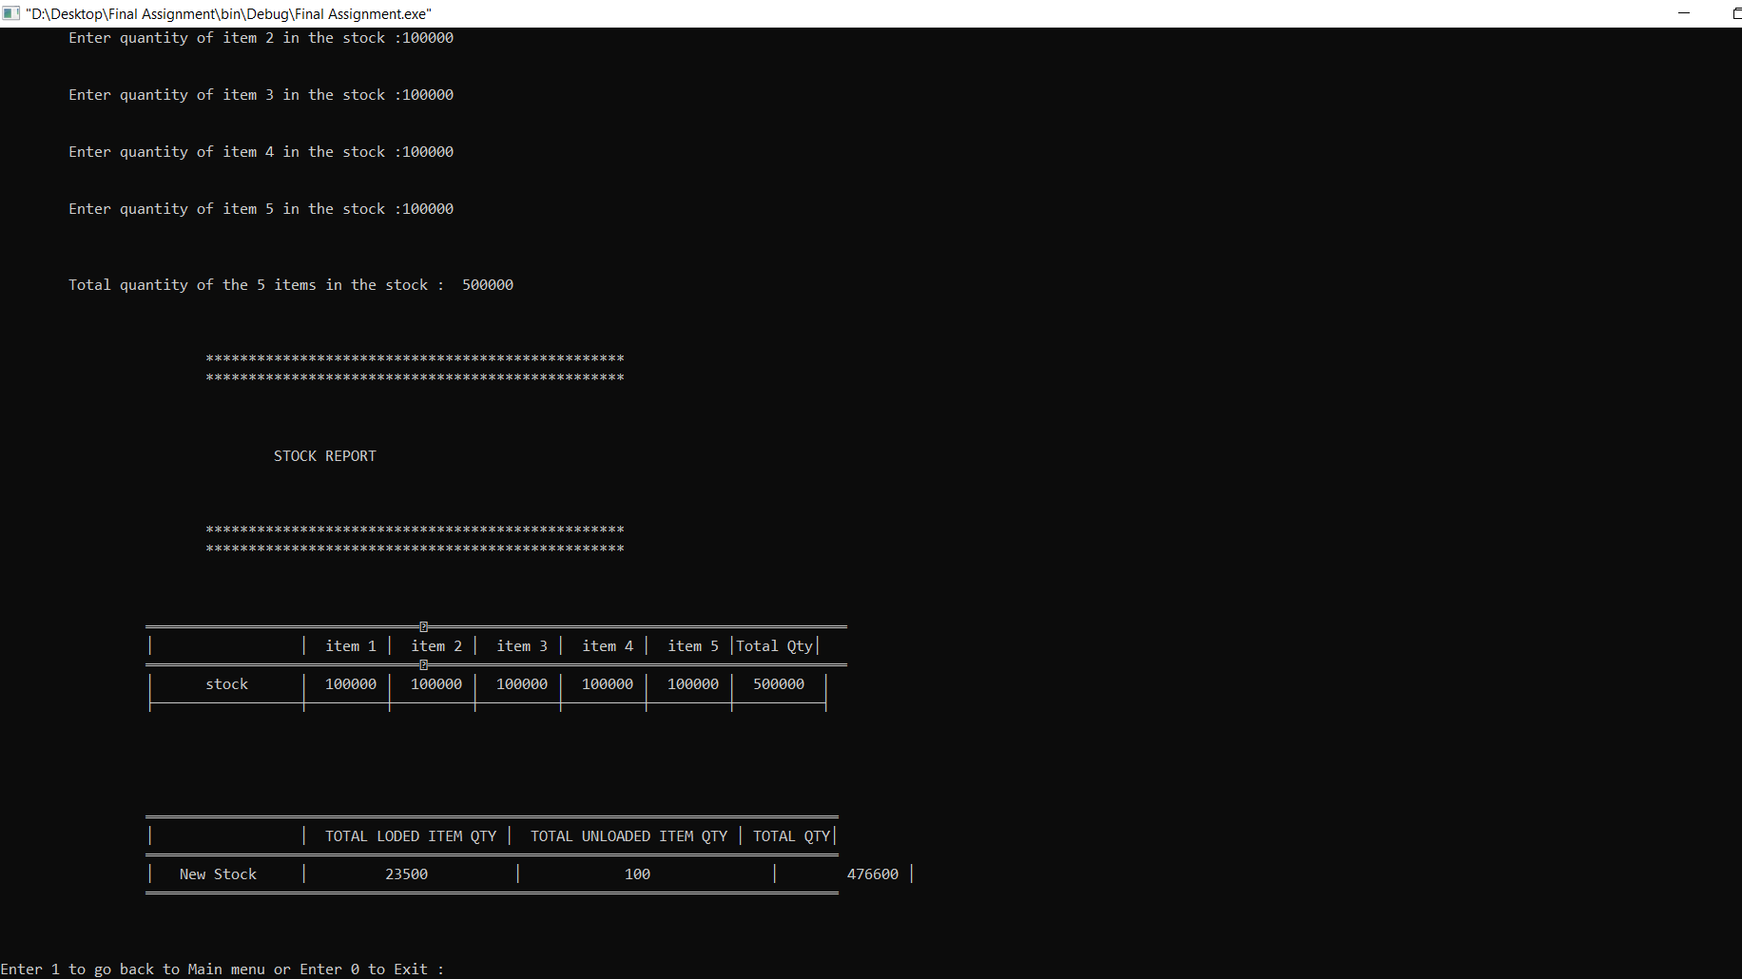

After that, the system will tell to EXIT or go back to MAIN MENU.

[05].Sales progress

In this function the progress of sale will performed at current date.

The user can get the report of sales using unloading and loading data.

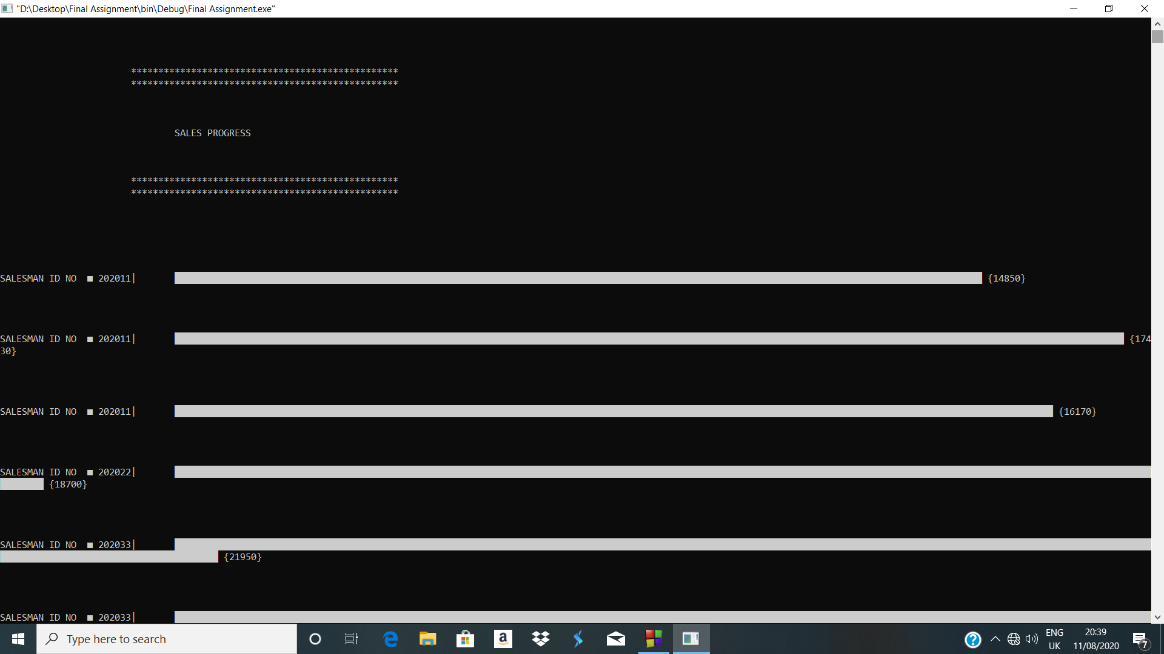

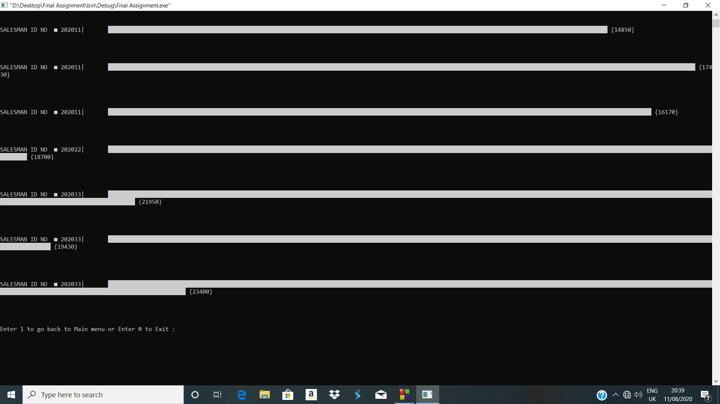

After that, the system will tell to EXIT or go back to MAIN MENU.

[06].View sales record

This function is declared as sales_record(); function. User can get the record of sales at current date.

After that, the system will tell to EXIT or go back to MAIN MENU.

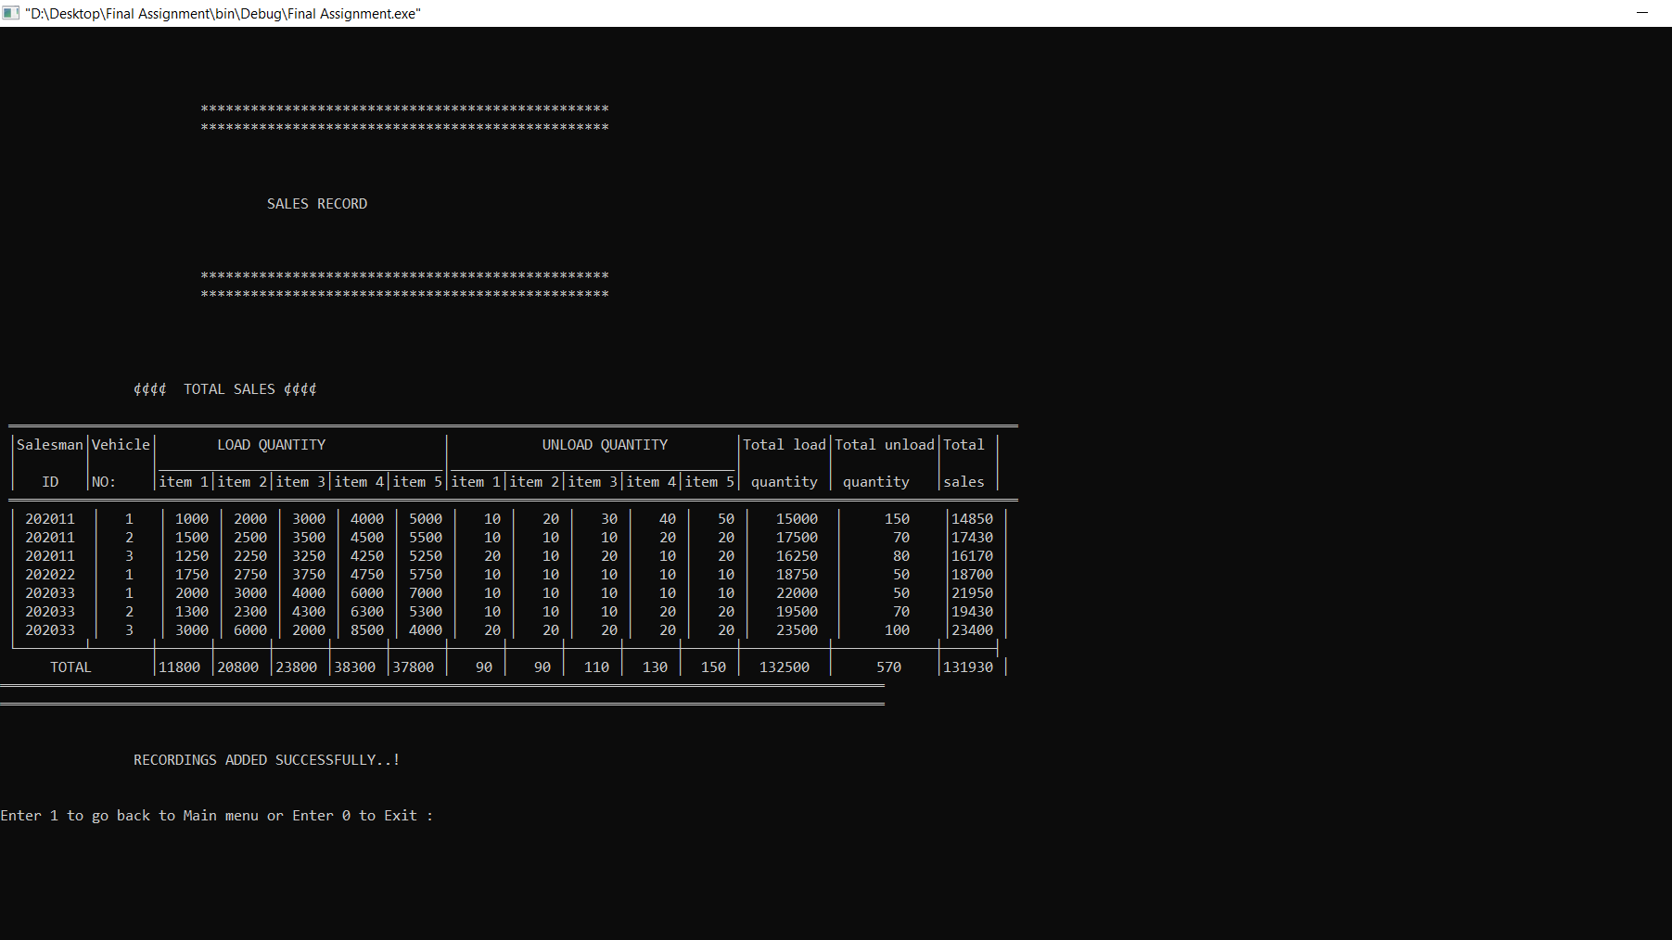

[07].Exit from the system

This function was used to the exit from the whole system.

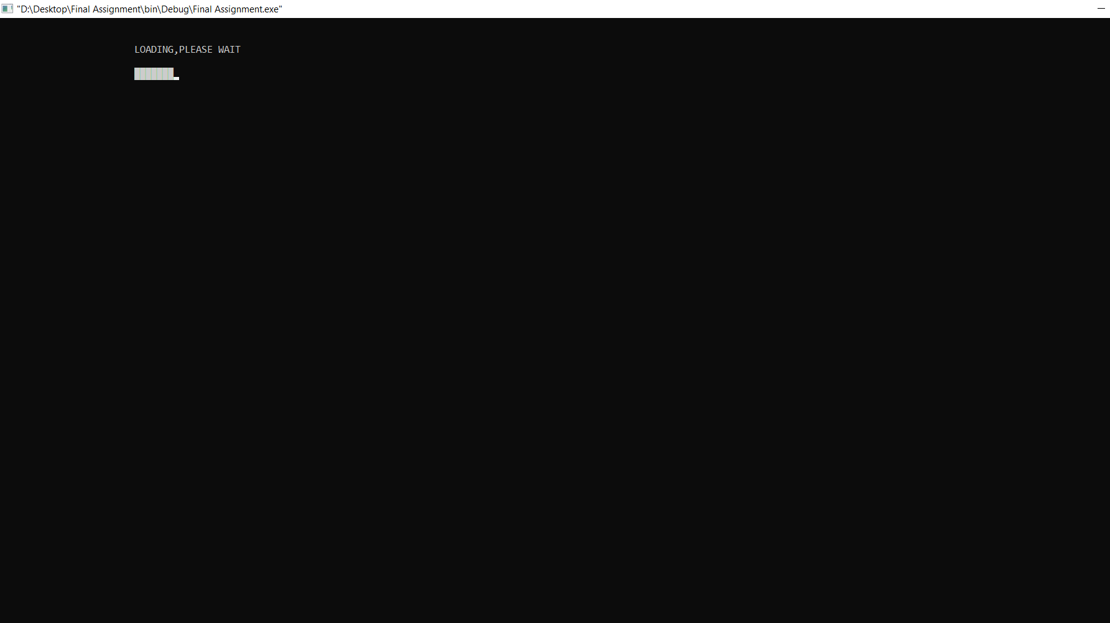

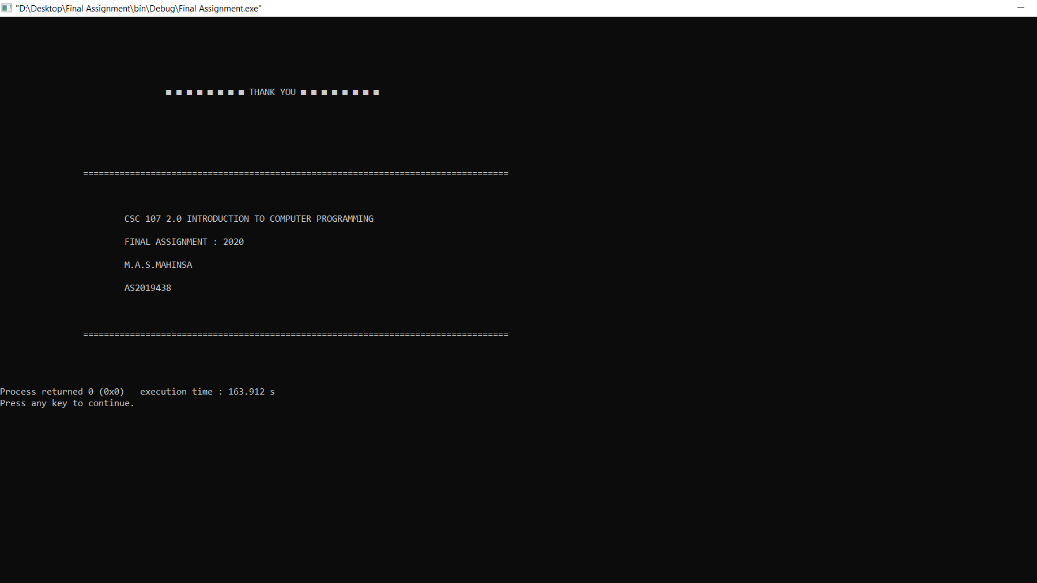

1. Other functions

In this program I`ve used few more function in order to make it better.

1. Delay
2. Close
3. Graph of sales

1]. Delay()

This function will keep the current activity on program few more minutes(or seconds) before go to the next interface.

2]. Close()

This function is created in program that will used when exiting from the system.

3].salesProgressGraph( )

This function is used to create the progress graph of salesmen.

1. Data structures

* char salesmanName[20]
* char date[10]
* int salesmanID
* int vehicleNo
* int item1Quantity
* int item2Quantity
* int item3Quantity
* int item4Quantity
* int item5Quantity

1. Validations

* In the main menu the default case is created to close the program or try again.

Which the code is;

default:

system("cls");

printf("\n\t\tINVALID CHOICE.....???");

printf("\n\n\nEnter 1 to go back to Main menu or Enter 0 to Exit :");

scanf("%d",&mainExit);

if(mainExit==1)

{

system("cls");

mainmenu();

}

else if(mainExit==0)

{

system("cls");

close();

}

else

{

system("cls");

printf("\n\n\n\tINVALID INPUT....???");

}

break;.

* In the exit from function, have two option which is go back to main menu or exit from system. And the code of exit:

exit:

system("cls");

int mainExit;

printf("\n\n\nEnter 1 to go back to Main menu or Enter 0 to Exit :");

scanf("%d",&mainExit);

if(mainExit==1)

{

system("cls");

mainmenu();

}

else if(mainExit==0)

{

system("cls");

close();

}

else

{

system("cls");

printf("\n\n\n\tINVALID INPUT....???");

goto exit;

}

File handling

in this program I used 4 files to write the data. Which are:

* *loadRecod.txt*
* *unloadRecod.txt*
* *stockRecord.txt*
* *salesrecord.txt*

1. **Bugs**

* When the user did not enter the correct data type, the system will no longer to finish the program correctly. Such that;
* Characters
* Integers

And when the loading or unloading data are not appropriate to the program data type or amount then, the system will not do the work correctly.

**And the text case that added in the document file , the sales progress bar chart seems not appropriate. So if I consider a limit for items quantity, there will be proper clean bar chat for sales progress details**.

**(6)limitations**

* The system has only 5 items.
* And the salesman name should be as the given example
* The data also should be as the given example